AVT Bitcounter: How to collect MB statistics

Internal Release Version 1.01 (DRAFT)
Date: March, 2000
Developed by: Qiong Gu
________________________________________________________________________

How to get the bit number for macroblock?

IN MPEG-2, encode convert the video to the bit stream. The structure of bit stream is show in the FIG 1.3.

For every bitstream, it has the start code to indicate the start of bitstream and the group-start code tell the start of every GOP. It uses the Picture-start-code to separate every picture in GOP and it uses slice-start-code to separate the slice. Since slice is a consecutive series of macroblocks which are all located in the same horizontal row of macroblocks. According to Fig 1.3, we can get that how many bits are allocated to every picture even for every macroblock.

In the AVT system, encoding process decided bits allocation. Like the picture show in below: Modules like Motion Estimation, DCT, quantiaztation decided how to convert the macroblock of picture and VLE generate the bit for this macroblock. So if we know the total bit numbers in the bitstream before and after the macroblock be encoded, we will know how many bits are generated for this macroblock.

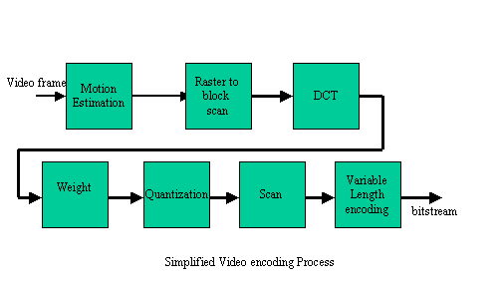

How we get it?

In the AVT system, there is a function called bitcount() (In putbits.c file), it will tell how many bits the encoder has generated for the bitstream.. So we insert this function into file
Putseq.c and putpic.c to get the bits for the header and the macroblock.

Usage :

I have put the code in bristi.facnet.mcs.kent.edu, named AVTbit.tar.
% tar –xvf AVTbit.tar //untar code
% cd AVT33/test // goto test directory
% make // compile
% ./ftest // test system

The input bitstream should be copy into test.m2v.
The prarameter file shold be copy into test.par
Put the bit rate into rate.par (you can find it in test.apr)

The out put the MB level bit will store in “BITfile”. Example:

At the begin, the total bits is 0
Bits for seqhdr and seqext and seqdispext is 592
Start to encode the frame BIT is 651
picture head is 135
slice head is 44
417 451 496 440 600 607 492 493 // bit for macroblock
slice head is 44
585 591 697 576 625 749 734 818
slice head is 41
866 836 842 905 1013 1062 788 1080
slice head is 40
1330 1632 2070 2144 2074 1207 1301 1979
slice head is 39
1882 2207 2358 2107 1013 1141 1890 1474
slice head is 40
470 692 1379 1877 1778 1610 1485 1451
slice head is 42
954 1169 1505 1295 1924 1998 1311 1488
slice head is 44
1925 1773 1984 1819 2092 2190 1738 1150

The out put SNR stats will store in “SNRfile”. Example:

Encoding frame 0
SNR for Y : display h=128 w = 128 extend h=128 w = 128 lx=128
20.1 17.1 52 50 43.7 14.4 43.2 49.5
20.1 43.6 46.7 44 51.9 101 47.6 56.7
50.5 45.2 47.4 43.5 49.1 28.7 39.2 37.8
42.1 29.1 34.3 34.8 38.5 32.1 40.8 39.3
39.4 38.2 36.5 41.7 40.8 42.4 43 37.4
35.4 15 29.7 35.8 40.7 37.5 37.4 40.8
16.7 35.1 34.5 34 38.2 41.2 41.6 35.6
34.4 38.4 37.7 36.9 37.7 39.6 35.7 28.6

SNR for U : display h=64 w = 64 extend h=128 w = 128 lx=64
11.8 10.4 0 21.2 0 11.2 0 0
11.8 0 75.9 0 80.2 75.1 77 72
0 0 72.3 76.2 79.2 21 70.7 70.7
78.5 0 13.7 16.8 21.4 11.8 20.1 22.5
0 23.2 24 22.4 24.7 29.9 22.2 75.5
19.9 72 19.3 19.3 26.9 22.6 14.2 16.5
0 83 83.2 22.2 21 22.2 13 22.9
24.6 25.8 26.6 24.9 19.2 21.1 22.1 20.4

SNR for V : display h=64 w = 64 extend h=128 w = 128 lx=64
11.8 0 0 21.2 0 12.6 0 0
11.8 0 0 0 0 78.4 74.2 81.3
74.6 0 0 0 75.9 16 78.5 80.1
0 7.78 14 13.6 15.8 76.4 27.2 30.7
26.4 33.6 34.9 25.8 25.9 26.7 25.1 21.8
34.9 7.78 18.6 36.2 23.2 28.2 17.2 21.3
0 32.6 31.5 36 20.4 21.3 23.8 22.7
40.2 16.8 11.3 29.4 24 24.8 19.6 75.1

